CNRC Letter of Commendation for Service Members, non-DEPpers

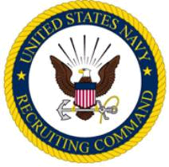

The Commander Navy Recruiting Command takes pleasure in Commending

RANK (if applicable)
FNAME MI LNAME
Branch of Service (if applicable)

for service as set forth in the following

- CITATION-
For commendable achievement in the performance, of his/her duties while serving at COMMAND NAME from Month Year to Month Year. Title Lname was responsible for the enlistment of one officer applicant who enlisted into the Navy from the City, St area. Title Lname’s performance was in keeping with the highest traditions of the United States Navy.

J. F. KILKENNY
RDML, U.S. Navy

