(SAMPLE)

CO Letter of Commendation for Service Members

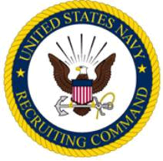

The Commander Navy Recruiting District ----- takes pleasure in Commending

RANK (if applicable)
FNAME MI LNAME
Branch of Service (if applicable)

for service as set forth in the following

- CITATION-
For commendable achievement in the performance, of his/her duties while serving at COMMAND from Month Year to Month Year. Title Lname was responsible for the enlistment of two qualified new contracts who enlisted into the Navy from the City, St area. Title Lname’s performance was in keeping with the highest traditions of the United States Navy.

Commanding Officer

